These instructions show users how to run the Gibbs code using WRDS’s SAS studio service. After the initial setup, the process takes XXX hours.

1. Go to the WRDS SAS Studio:

<https://wrds-cloud.wharton.upenn.edu/SASStudio/>

1. On the left-hand-side, navigate to your institution’s folder in the /Scratch/ directory: 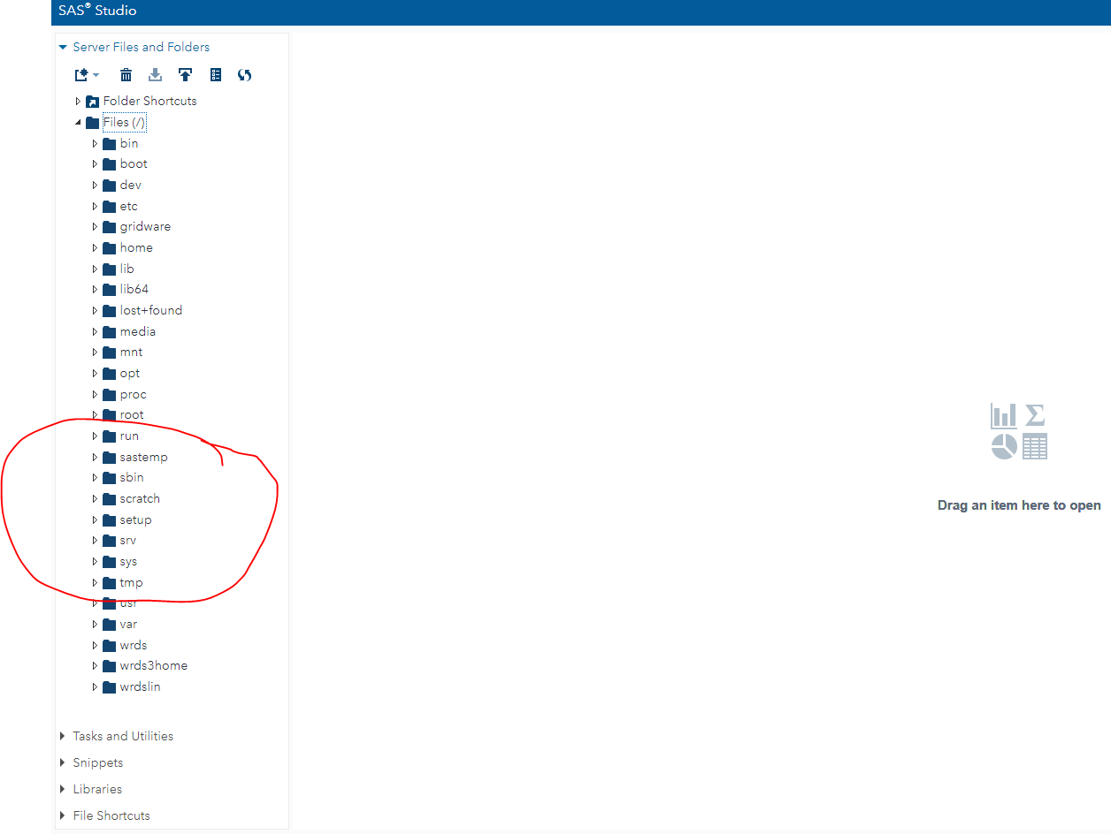
2. Create a new folder there by right clicking on your institution. This is wGibbhere the SAS code will store temporary tables and the final .csv output:

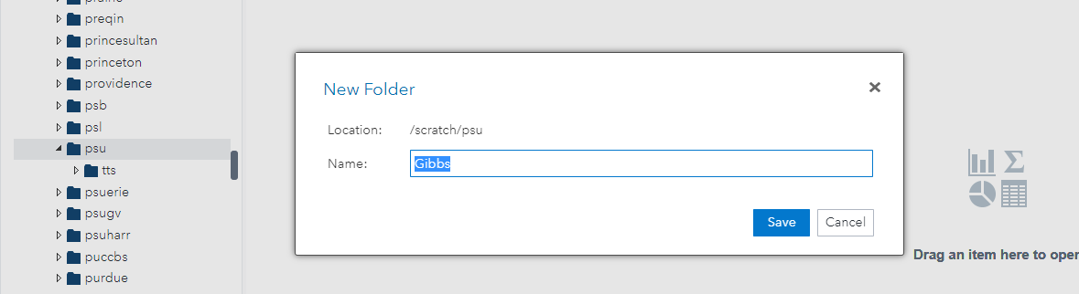

1. Upload the two .sas files (crspGibbsBuildv01.sas and RollGibbsLibrary02.sas) to the folder you just created by right clicking on it and then clicking “Upload Files…”:

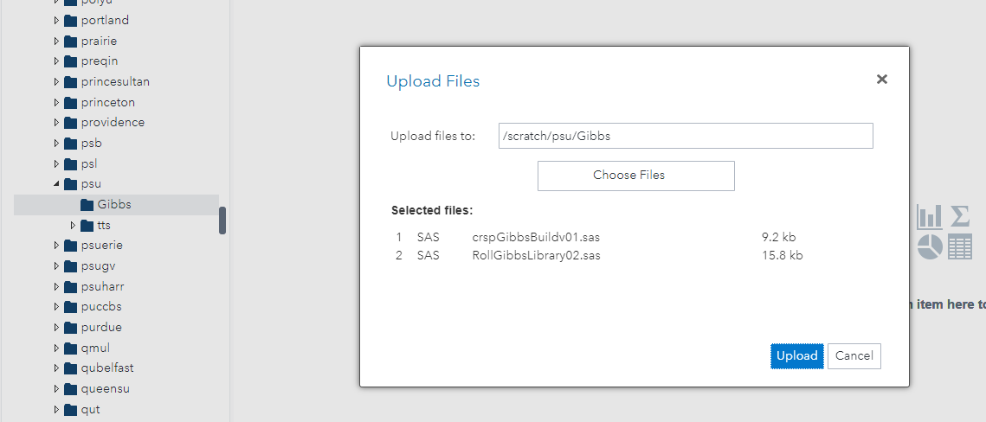

1. Open the RollGibbsLibrary02.sas file in SAS studio by double clicking on it.
2. Edit the library name on the top of the file to match the folder you just created:

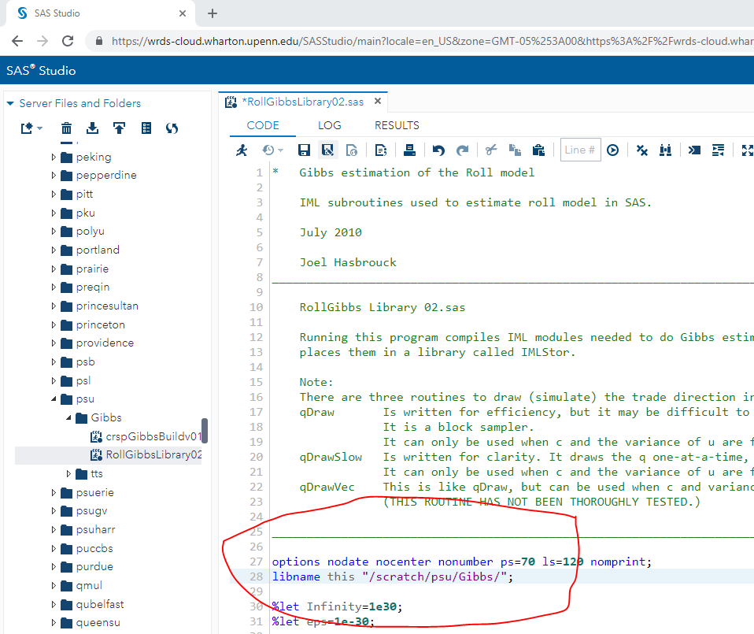

1. Run the RollGibbsLibrary02.sas by pressing F3 or using the Run code icon 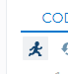
2. Open the crspGibbsBuildv01.sas file in SAS studio by double clicking on it.
3. Edit the library names on the top of the file to match the folder you just created:

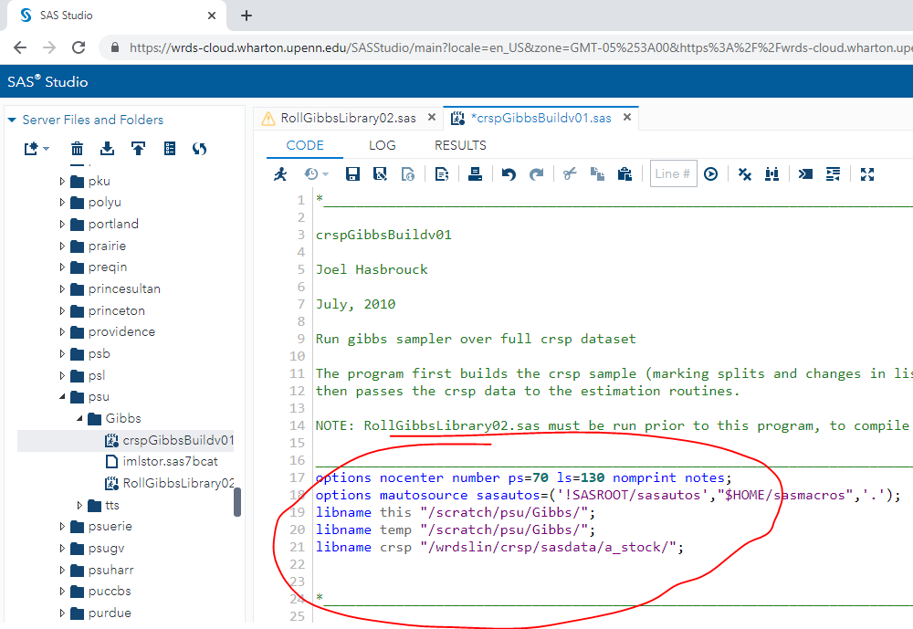

1. Run the RollGibbsLibrary02.sas by pressing F3 or using the Run code icon 
2. The output file will be in the folder you created and will be called crspGibbsv01.txt